机电工程专业英语 翻译作业 一 上海大学机电工程与自动化学院 秦磊 (10121409)

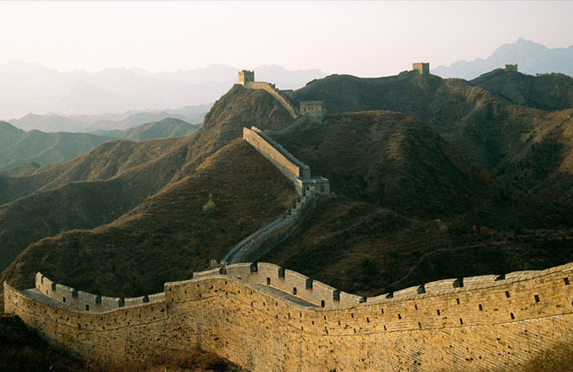
The Great Wall of China is the largest construction ever built by man. It was built over 2000 years ago and was originally used to protect the northern borders of the China from intrusions. Since then, several walls have been built. Collection of all such walls is referred to as The Great Wall.

Since the Qin Dynasty, the Great Wall has on and off been rebuilt, maintained, and enhanced; the majority of the existing wall was reconstructed during the Ming Dynasty. Unlike the earlier Qin fortifications, the Ming construction was stronger and more elaborate due to the use of bricks and stone instead of rammed earth.

中译文：
长城是人类历史上最宏伟的建筑，她最初是被用来抵御外族侵略的。
秦朝覆灭之后，长城被屡次翻修和加固；而现存的长城大多是明朝时重新修建的。不同于用土夯实的秦代长城，明朝使用砖石修葺，因此也更加坚固。

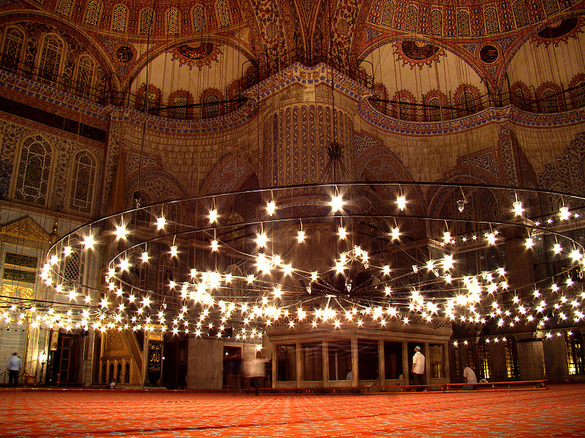
The beautiful Mosque of Istanbul, known as the Blue Mosque, is the central element of the complex built by Ahmed I (1603-1617) and was completed in 1616. The design of the Sultan Ahmed Mosque is the culmination of two centuries of both Ottoman mosque and Byzantine church development. It incorporates some Byzantine elements of the neighboring Hagia Sophia with traditional Islamic architecture and is considered to be the last great mosque of the classical period.
中译文：
苏丹皇太后清真寺由艾哈迈德一世于1616年建成。建筑的设计不仅保留了传统的伊斯兰风格，并将发展了200多年的拜占庭式教堂元素融入其中。她也由此被认为是古典时期最后一座宏大的清真寺。

资料序号 名称 出处 资料形式 备注
[1] 10 Incredible Architectural Wonders of The Ancient World 网页
http://www.smashinglists.com/10-incredible-architectural-wonders-of-the-ancient-world/
[2] Great Wall of China 网页
http://en.wikipedia.org/wiki/Great_Wall_of_China
[3] Sultan Ahmed Camii 网页
http://archnet.org/library/sites/one-site.jsp?site_id=3006
[4] Sultan Ahmed Mosque 网页
http://en.wikipedia.org/wiki/Sultan_Ahmed_Mosque
备注:
2012年09月08日

